|  |  |
| --- | --- |
| **Practicum Case** |  |
| COMP6708  Object Oriented Programming |
| **Computer Science** | **O221-COMP6708-LI01-02** |
| ***Valid on*** *Odd Semester Year 2021/2022* | **Revision 00** |

## Learning Outcomes

* The main features of OOP
* The additional features of OOP
* A program using additional features of OOP

## Topic

* Wrapper Class and Method

## Subtopics

* Wrapper Class and Method
* String Class and Method
* Build in class and method in Java (Math, String, Date, etc)
* Type Casting Variable
* Exception Handling

## Soal

*Case*

**Subject**

**Subject** is a simple program that helps to introduce **Math** and **English** subject to elementary students. As a popular programmer in your city, you are asked to make this simple program using several topics such as **wrapper class and method**, **string class and method**, **build in class and method**, **type casting variable**, and **exception handling**.

* The program will consist of 3 menus:

1. Mathematics
2. English
3. Exit

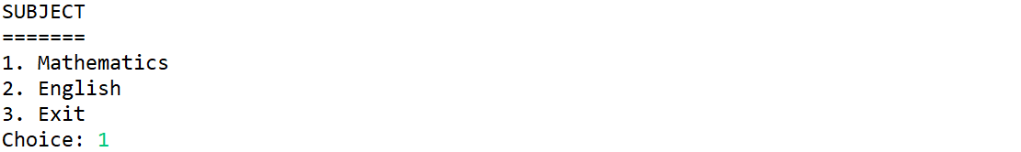

* If the user input 1, then:
* The program will show the sub menu inside Mathematics menu, the Mathematicssubject consists of 2 menus:

1. Calculate circle area
2. Calculate rectangle area

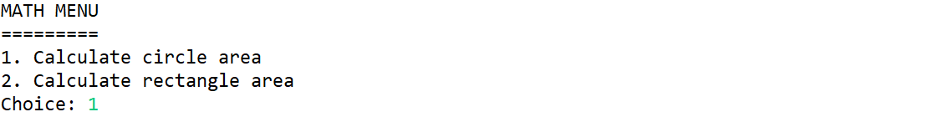

* If the user input 1 “**Calculate circle area**” menu, then the program will ask the user to input:
* **Circle type**, which must be“**Radius**” or “**Diameter**” (**Case Insensitive**)



* After the user chose the **circle type**, the program will **randomly** generate the **radius/diameter** from **1 – 100** (**inclusive**), then print the random result and the area
* The formula for finding the **Circle** **Area**, are:

|  |
| --- |
| If the user chose **radius**, then:  **Area** = **π** * **radius2**  If the user chose **diameter**, then:  **Area** = **π** * (**diameter/2**)**2** |

* After that, display the result as the following:

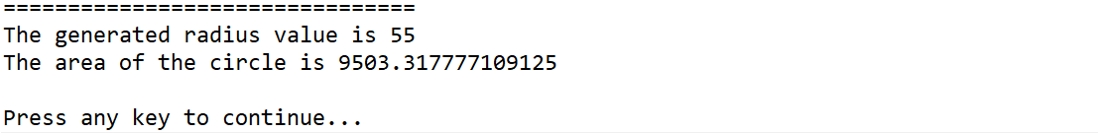

* If the user input 2 “**Calculate rectangle area**” menu, then the program will ask the user to input rectangle details:
* **Width** and **Length**, which must bethe same with the following format “**Width**x**Length**”



* After the user has inputted the **width** and **length**, calculate the **Rectangle Area** with the following formula:

|  |
| --- |
| **Area** = **width** * **length** |

* After that, display the result as the following:



* If the user input 2 for the **main menu**, then the program will ask the user to input:
* **Word**, which must beonly **one word** and **alphabet**



* **Tenses type**, which must be“**Present**” or “**Past**” (**Case Sensitive**)



* If the user chose “**Present**”, then check whether the end of the word **ends** **with** ‘**s**’ or ‘**es**’. If it ends with **either** one of it, then display the word as a “**plural word**”. If it **doesn’t** endwith **either** one of it, then display the word as a “**singular word**”. After that, display how many characters the wordhas

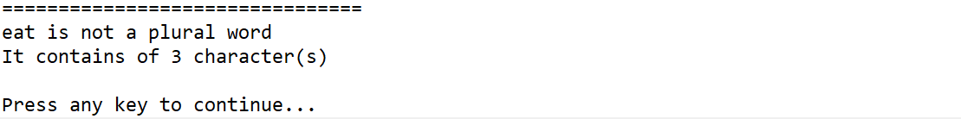

* If the user chose “**Past**”, then check whether the end of the word **ends** **with** ‘**d**’ or ‘**ed**’. If it ends with **either** one of it, then display the word as a “**regular verb**”. If it **doesn’t** end with **either** one of it, then display the word as an "**irregular verb**”. After that, display how many characters the wordhas

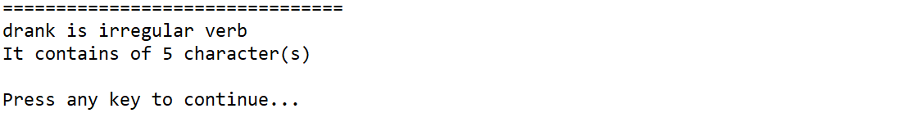

* If the user input 3 for the main menu, then the program will exit

**Please ask your teaching assistant if there are any related questions.**